**EXPERIMENT 8**

create table customer_exp8_csea_42(customer_id int primary key,customer_name varchar(20),contact_no number(10),address varchar(10),city varchar(20),postal_code number(10),country varchar(10));

table CUSTOMER_EXP8_CSEA_42 created.

DESC customer_exp8_csea_42;

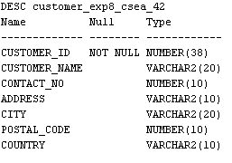

CREATE TABLE EMPLOYEES_EXP8_CSEA_42(EMPLOYEE_ID INT,LAST_NAME VARCHAR(20),FIRST_NAME VARCHAR(20),BIRTHDATE VARCHAR(20),PHOTO VARCHAR(20),PRIMARY KEY(EMPLOYEE_ID));



DESC employees_exp8_csea_42;

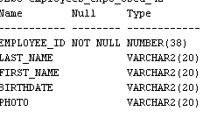

CREATE TABLE ORDERS_EXP8_CSEA42(ORDER_ID INT PRIMARY KEY,CUSTOMER_ID INT,EMPLOYEE_ID INT,ORDER_DATE VARCHAR(20),SHIPPER_ID INT,FOREIGN KEY (EMPLOYEE_ID) REFERENCES EMPLOYEES(EMPLOYEE_ID),FOREIGN KEY (CUSTOMER_ID )REFERENCES CUSTOMER(CUSTOMER_ID));



DESC orders_exp8_csea42;

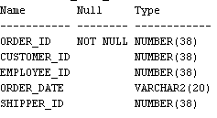

INSERT INTO CUSTOMER_EXP8_CSEA_42 VALUES (1 ,'MANOJ', 9495929133, 'PANACKAL', 'KOCHI', 632132, 'INDIA');

INSERT INTO CUSTOMER_EXP8_CSEA_42 VALUES (2, 'SARA' ,382738219, 'KATHATI', 'TVM' ,987654, 'USA');

INSERT INTO CUSTOMER_EXP8_CSEA_42 VALUES(3, 'SAMUEL', 353738219, 'KATHA', 'TTHRISSUR', 667654, 'UK');

INSERT INTO CUSTOMER_EXP8_CSEA_42 VALUES(4, 'NIYA', 987738219, 'MANIYAK', 'PERRUR', 627654, 'UK');

INSERT INTO CUSTOMER_EXP8_CSEA_42 VALUES(5, 'DIYA', 887738219, 'THAZHATH', 'MALABAR', 697654, 'USA');

SELECT * FROM CUSTOMER_EXP8_CSEA_42;

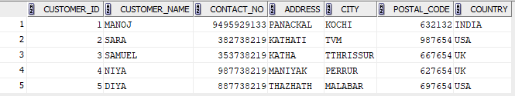

INSERT INTO EMPLOYEES_EXP8_CSEA_42 VALUES(1,'SABU', 'NEHA', 28-09-2004, 'PHOTO1');

INSERT INTO EMPLOYEES_EXP8_CSEA_42 VALUES(2,'JOSE', 'SNEHA', 18-09-2004, 'PHOTO2');

INSERT INTO EMPLOYEES_EXP8_CSEA_42 VALUES(3,'MENON', 'NAGARAJ', 28-07-2004, 'PHOTO3');

INSERT INTO EMPLOYEES_EXP8_CSEA_42 VALUES(4,'FARHAN', 'MUHAMMED', 13-09-2004, 'PHOTO4');

INSERT INTO EMPLOYEES_EXP8_CSEA_42 VALUES(5,'EMMANUEL', 'MANU', 18-03-2004, 'PHOTO5');

SELECT * FROM employees_EXP8_CSEA_42;

